ac

Syndax 4Q and FY 2025 Earnings; Highlighted 1L AML and post-transplant maintenance expansion plans; steady post-launch uptake in R/R AML

Company: Syndax  Drug: Revuforj (revumenib; Menin-MLLi) | Date: Feb 26, 2026  Source(s): Presentation, Press Release, Webcast
What happened:
- Syndax released its 4Q and FY2025 earnings, highlighting commercial progress for Revuforj following its Oct 2025 label expansion in R/R NPM1m AML, with FY 2025 revenue of $124.8M
- The company provided updates on its 1L AML development program:
  - Advancing global enrollment in pivotal Ph 3 EVOLVE-2 (1L KMT2Ar or NPM1m unfit AML) and Ph 3 REVEAL-ND NPM1 (1L NPM1m fit AML) studies (reiterated)
  - Plans to initiate a Ph 2 RAVEN (revumenib + Ven + Aza, 1L KMT2Ar fit AML) study in 2H 2026 (additional granularity, previously 2026)
  - Data from Ph 1/2 BEAT-AML (1L NPM1m or KMT2Ar unfit AML, revumenib + Ven + Aza) expected in 2H 2026 (new guidance)
- Syndax for the first-time officially disclosed development plans for Revuforj in post-transplant maintenance setting, including the Ph 1 BALL (KMT2Ar or NPM1m post-transplant maintenance AML, revumenib, N=27) study in its pipeline, despite being a ISS
  - This study is currently in dose optimization stage and data are expected in 2026 (new guidance)
- During Q&A, management provided guidance on R/R NPM1m AML adoption trajectory (≥30% of new starts in 4Q, expected to grow further), rationale supporting the development in the post-transplant maintenance setting, emphasized on 2026 focus in advancing 1L AML pivotal studies and present data in post-transplant maintenance setting

Approval timelines:
 | US | EU
R/R NPM1m AML  (AUGMENT-101; revumenib) | Oct 24, 2025  (Approved) | NA  (While development plans in the EU remain unclear, Syndax recently partnered with WODA for expanding Revuforj access in Eurasia, Central and Southeast EU)
1L NPM1m or KMT2Ar unfit AML  (Ph 3 EVOLVE-2;  revumenib + Ven + Aza) | 3Q 2028 (AA)  (CI assumptions based on CR data readout in 2028; no changes to timelines) | 1Q 2031  (CI assumptions based on Dec 2029 PCD; no changes to timelines)
1L NPM1m fit AML  (Ph 3 REVEAL-ND NPM1; revumenib + 7+3) | 3Q 2028 (AA)  (Aggressive CI assumptions based on in-class analogues; no changes to the timelines) | 3Q 2030  (CI assumptions based on Jun 2029 PCD; no changes to timelines)
Impact (CI PoV): MEDIUM
- Syndax is advancing Revuforj as a backbone menin inhibitor across AML subsets and LoTs, from frontline through R/R with strong post-launch uptake, and post-transplant maintenance, aiming to establish early treatment anchoring and lifecycle continuity
- While Ven may gain incremental traction from triplet use in 1L unfit AML, its shortened dosing schedule could structurally constrain long-term revenue durability

Why it matters (CI Insights in blue italics):

Clinical and Medical Strategy:
1L AML
- The company emphasized positioning Revuforj as a "targeted anchor" therapy across the AML treatment continuum from R/R to 1L, aiming to be "first to the frontline” menin inhibitor-based regimen
- Syndax is aiming to position Revuforj as elected menin inhibitor for AML, establishing leadership across molecular subsets (KMT2Ar and NPM1m) and embed the asset through the full treatment paradigm, from 1L to R/R and post-transplant maintenance
  - It is important to notice that in 1L fit setting KMT2Ar remains at earlier stages than NPM1m
  - In 1L unfit AML, while the company is aggressively advancing the pivotal trial using standard Ven schedule, data from the BEAT-AML study (Ven 14d), expected in 2H 2026, may inform a potential official reduction of Ven to 14 days
Post-transplant maintenance AML
- Company reported that ~33% of KMT2Ar patients proceed to transplant, and of those, ~40-45% have resumed Revuforj post-transplant (updated guidance; up from 35-40% in 3Q 2025)
  - During Q&A, management noted that post-transplant resumption rate is expected to reach ~70-80%
- Management differentiated the opportunity by subtype:
  - For KMT2Ar population, the maintenance is more impactful as it enables a post-transplant strategy that previously did not exist
  - NPM1m population will have fewer transplants and thus fewer patients in maintenance setting
Real-World Evidence Outlook
- Management indicated that additional real-world data are expected throughout 2026, further differentiating revumenib's clinical profile (new guidance)

Commercial Updates:
R/R AML
- Formulary Access: Time from prescription to patient access is ≤4 days, with reimbursement at approximately 97-98% in KMT2Ar and 97% formulary coverage achieved in NPM1m just 4 months post-approval
- Real-world use: ~70% of use is in 2L-3L (earlier lines of treatment), and combination use has grown to 40% (up from 33% in 3Q 2025)
- The growing real-world adoption of Revuforj, particularly its 40% use in combination and earlier LoTs, signals a deliberate company’s strategy to penetrate the frontline setting, secure early treatment anchoring, and drive sustained utilization across subsequent LoTs, as patients remain on familiar regimens
- Prescriptions & Patients: Total prescriptions in 4Q 2025 reached ~1,150 (~35% QoQ). New patient starts increased by ~20% QoQ (~300 patients), driven primarily by NPM1m uptake, with approximately 3,350 total prescriptions written
  - Management indicated that NPM1m represented ≥30% of new patient starts in 4Q25, up from ~20% in 3Q and ~10% earlier in the year 2025
  - Company described the launch dynamic as an "on-ramp" accelerating, with momentum continuing into 1Q 2026, and expects NPM1m share to grow even further given the larger patient population
- Treatment Duration: Average treatment duration in 2025 was 4-6 months, and management expects this to extend to 6-12 months in 2026 as treatment patterns mature
- Competitive Positioning: Management reiterated Revuforj's competitive advantages, citing “unmatched efficacy data across multiple patient subtypes, strong prescriber base and HCP familiarity, excellent payer support and reimbursement, and proven track record of delivering for patients”
  - During Q&A, management noted lack of significant competitive impact and expressed confidence in dominating the space, given a superior product profile and execution capabilities
  - Company sees no structural barriers to increasing KMT2Ar penetration, citing lack of approved alternatives and poor outcomes with standard therapies
- Syndax is strategically leveraging its first-to-market advantage to outpace in-class competitor Komzifti (ziftomenib), capitalizing on established HCP familiarity and robust payer and reimbursement infrastructure, capabilities that Kura needs to build considering it entered the AML market ~1 year later Revuforj with its first approval in R/R NPM1m AML in Oct 2025

Tell me more:

Financial Highlights
- Management highlighted a "robust balance sheet" and expects to reach profitability without additional capital given growing revenues and stable expenses

USD | 4Q 2025 (Global)
Cash, cash equivalents, and short-term investments (as of Dec 31, 2025) | $394.1 M

Global sales (USD) | Total Revenue | Revuforj Net Sales
4Q 2025 | $68.7 M | $44.2 M
3Q 2025 | $45.9 M | $32.0 M
QoQ change | +50% | +38%
FY 2024 | $ 23.7 M | $7.7 M*
FY 2025 | $172.4 M | $124.8 M
YoY change | +628% | +1521%
*Note: 4Q 2024 Revuforj sales represent the initial 5 weeks of launch following FDA approval on Nov 15, 2024. Approximately one-third of this amount represented inventory at specialty pharmacies and distributors, with the remainder representing patient demand

Key Upcoming Milestones
Milestones | Timelines
Initiation of Ph 2 RAVEN (revumenib + Ven + Aza) study in 1L KMT2Ar fit AML | 2H 2026 (additional granularity, previously 2026)
Data from Ph 1/2 BEAT-AML (1L NPM1m or KMT2Ar unfit AML, revumenib + Ven + Aza) | 2H 2026 (new guidance)
Data from Ph 1 BALL (KMT2Ar or NPM1m post-transplant maintenance AML, revumenib, N=27) | 2026 (new guidance)

Relevant Slides:
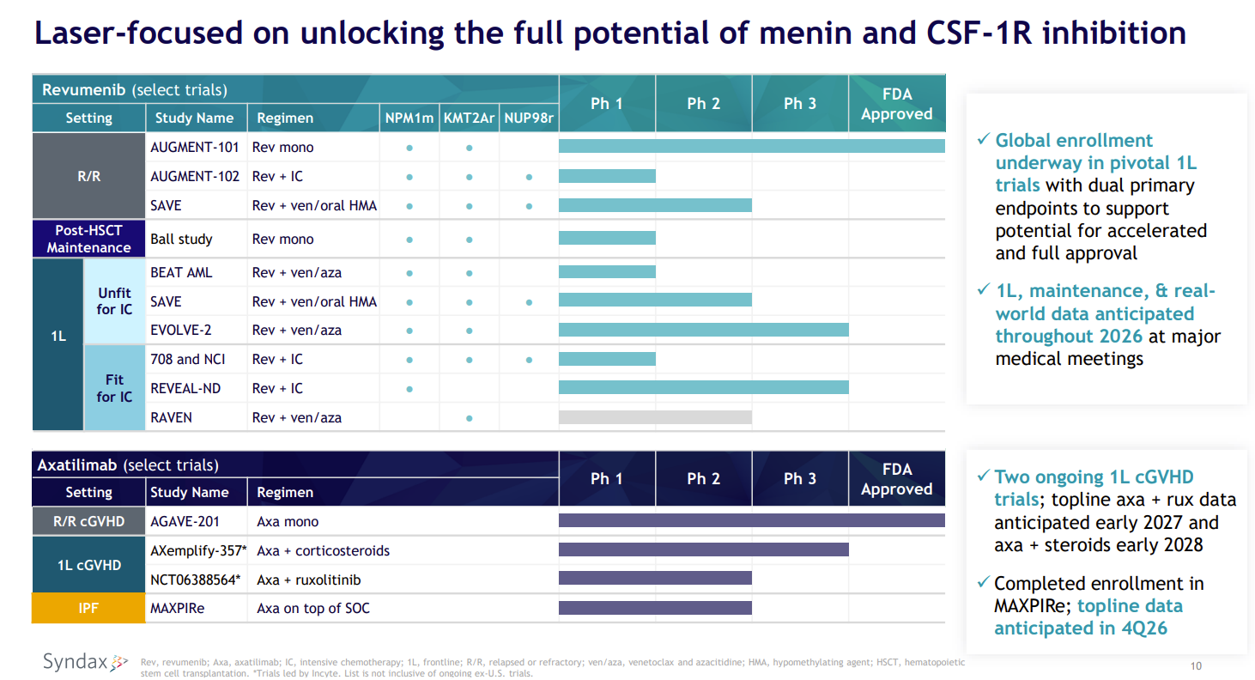
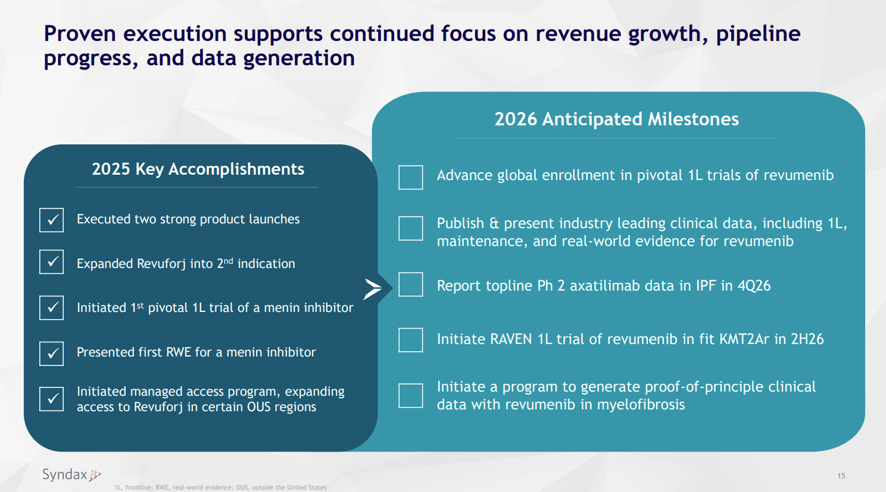

For questions, please reach out to:
International / Affiliates: Harjit Bajwa
US: Richa Sharma

Invite your colleagues to CI Edge | Manage Email Preferences | Unsubscribe
This document/email contains competitive intelligence collected via an approved competitive intelligence supplier working on behalf of AbbVie. We collect competitive intelligence consistent with industry standards and AbbVie policy. Not for field distribution. Please reach out to APEX/IMABI, Legal, or OEC teams with any questions.

